**TribeDAO-Giveth Token Swap & Collaboration**

**TL;DR**

* Giveth is planning to launch its own Rari Fuse pool called the "Regen pool" incentivizing FEI deposits which Giveth will borrow $500k-$700k, collateralized by GIV.
* The rewards scheme will be similar to other reward mechanisms in our GIVfarm, distributed through the GIVsteam, providing rewards over time until the end of the GIVstream.
* We are also launching our oneGIV stablecoin with ICHI Angel Vault and will seed it with FEI deposits.
* The vault will be a low-risk Univ3 pool actively managed by Giveth team.
* We want to use this vault to generate liquidity for our FEI backed stablecoin oneGIV
* We will use this to pay our contributors, fill our matching pool for donations (donation.eth), and other significant projects on our roadmap.
* We understand the risks and will actively manage and proactively collateralize our positions with FEI.
* We will create a significant demand for FEI and would like to ask the FEI/TRIBE community for a 50-50 FEI and TRIBE token swap to support our project.

**Introduction**

Giveth is going to launch its own Rari Fuse pool (the “Regen Pool”) in order to initially collateralize its own FEI-backed stablecoin (oneGIV), and a structured Univ3 Pool .

We are excited to have our own oneGIV token and ICHI’s setup for a branded dollar is the best solution we could find, as it allows us to create a stablecoin that is backed by FEI and GIV. We will use the oneGIV token to keep our matching pool stable and pay our contributors, provide liquidity for the GIV token, encourage donars to use it for donating to for-good projects, and for many other upcoming projects in our roadmap. Their angel vault is a really nice Univ3 structured pool that maximizes the liquidity for both GIV and oneGIV on the most important exchange out there. We are aware of the recent risks involved with the Angel Vault which is why we have decided to take the following measures to mitigate them:

* We will use this purely for our own infrastructure and won't be giving crazy yields to pump the market cap.
* We will keep this process relatively small, utilizing caps and holding the majority of the oneGIV created within contracts we control.
* Most importantly, we will take a proactive management approach. The vault will be managed by selected members of our governance team for controlling of the collateral & the process of collateralizing oneGIV. We will actively monitor the health of the token, using Token Engineering best practices.

In launching this system we will do various different liquidity mining incentives and all of them will greatly benefit the TribeDAO/FEI ecosystem, including using GIV to incentive FEI deposits into our Rari Fuse Pool.   
We would like to formalize our partnership in this effort with TribeDAO by offering a token swap and asking your community for support for launching our stable token.   
  
**The Deal:**  
  
Swap $250k of FEI and $250k of TRIBE for $500k of GIV  
  
We will use the FEI to add to the oneGIV liquidity and use the TRIBE to make a GIV/TRIBE Univ2 liquidity pool. We will not directly sell anything given to us without your consent and we would expect the same from you, it will only be used for liquidity.

We will determine the price of the tokens in advance upon a mutual agreement from both DAOs based on the market prices.

**Using GIV to create demand for FEI**

Giveth has several liquidity mining programs (check them out at <https://giveth.io/givfarm>). We would like to add FEI to our GIVfarm in two parts: using GIV to incentivize FEI deposits into our Rari Fuse Pool & using GIV to incentivize Angel Vault LP staking (which are made with 80% FEI).

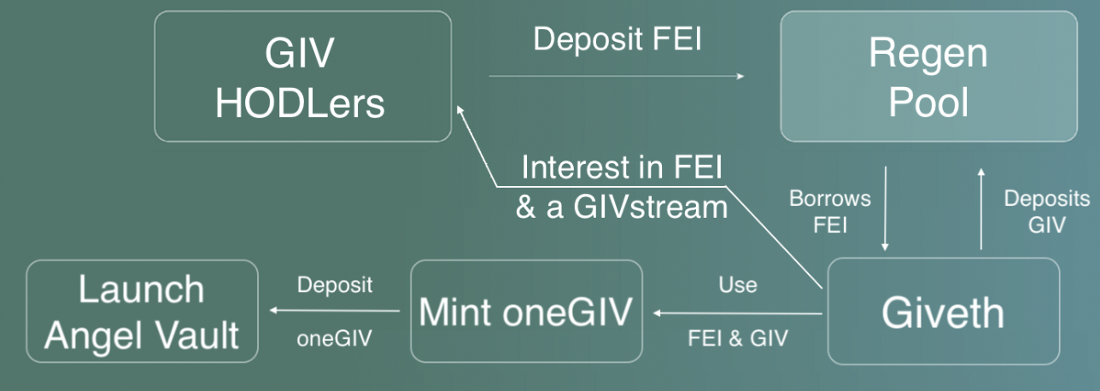

More on the Regen pool setup can be found [here](https://forum.giveth.io/t/regen-pool-the-path-to-an-angel-vault-and-maybe-much-more/529) and reward mechanisms [here](https://forum.giveth.io/t/lets-reward-depositors-who-contribute-to-our-regen-pool/638). In short, our Rari Fuse pool is called “Regen Pool” for future use cases, but our initial configuration will be very narrow in scope to reduce risk - set up to incentivize our community to deposit FEI & earn rewards, and for Giveth to borrow this FEI to launch oneGIV. For rewarding depositors we’re targeting a 20% APR for 1M USD worth of FEI deposited. With a supply cap for FEI of 3M the minimum APR will be ~6%.

We are very excited to launch oneGIV backed by FEI and start using GIV to incentivize FEI deposits. We would certainly be up for integrating more tools and expanding our collaboration with TribeDAO in the near future beyond this first huge step! We look forward to partnering up with TRIBE and ask for your support in this proposal to help our project take off the ground quickly.